TC-AUTH-002
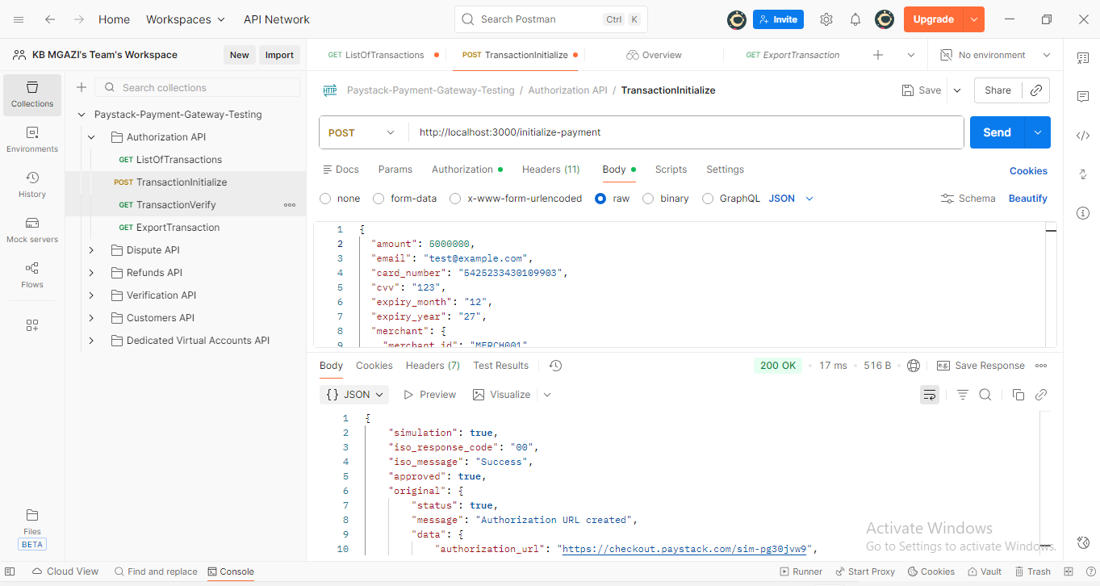
Request:
{
"amount": 5000000,
"email": "test@example.com",
"card_number": "5425233430109903",
"cvv": "123",
"expiry_month": "12",
"expiry_year": "27",
"merchant": {
"merchant_id": "MERCH001",
"name": "Mgazi Enterprise"
}
}

Response:
{
"simulation": true,
"iso_response_code": "00",
"iso_message": "Success",
"approved": true,
"original": {
"status": true,
"message": "Authorization URL created",
"data": {
"authorization_url": "https://checkout.paystack.com/4awl3rlasy3vssn",
"access_code": "4awl3rlasy3vssn",
"reference": "o7f89fgbkz" }
}
}
